# 

Operational Processes – Doorman role (Covid 19 Vaccines)

Covid 19 vaccine Clinic roles and system usage guide for NHS Trusts

Contents

1 Definition and Purpose 3

2 Preparing to Use the SimplyBook System 3

2.1 Requesting access for new users 3

2.2 Email received by Doorman advising of system access 3

2.3 System web access / URL 4

2.4 First logon (using email link) 4

2.5 Logging in to SimplyBook 4

2.6 Setting a new password for the system 5

2.7 Password resets and Requesting a new password 5

2.8 Making Sure to Log out of the System 5

3 The appointment Arrival and Validation process 6

3.1 Validating a Ticket in SimplyBook (if using a desktop computer/laptop) 6

3.2 If the Staff/patient arrives without their Ticket 7

4 How to facilitate a Walk-in Staff/Patient (without an appointment) 8

4.1 Dealing with Walk-ins 8

5 If your organisation is using the App from a Phone 9

5.1 Download the Simply Book App onto Service Phone Device 9

5.2 Accessing the SimplyBook App for the First time 9

5.3 Set a new password for the system 9

5.4 Validate Service User’s QR Code or ‘ticket’ (with a mobile and downloaded app) 9

1. Definition and Purpose

The system Book system has the following roles associated to it.

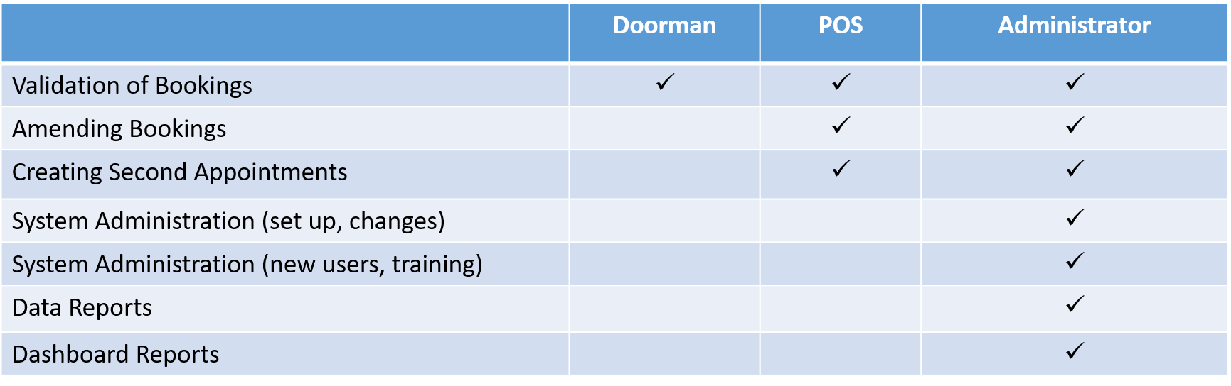

This booklet sets out the operational processes for the Covid 19 Vaccine clinic - **Doorman** role.

The **Doorman** role is responsible for capturing the arrival of patients/staff that have pre-booked a date & time slot to receive a Covid 19 vaccination at the clinic. The doorman uses the SimplyBook booking system to validate their appointment booking **Ticket** which they should have brought with them.

Should you not be able to find the support you require within this document, please contact the [**[Enter relevant email address]**](mailto:Covid.System@mcht.co.uk) mailbox, where one of the team will be able to assist.

1. Preparing to Use the SimplyBook System
   1. Requesting access for new users

To request access for new users, please contact the [**[Enter relevant email address]**](mailto:Covid.System@mcht.co.uk) mailbox and provide the following information for the new user:

* Full Name
* Email Address
* Contact phone number
* Type of access – i.e. Role & description of how the new user will be using the system – i.e. Doorman – Scanning and Validating Ticket.

Once actioned by the team, the new user will obtain an email with their joining instructions.

* 1. Email received by Doorman advising of system access

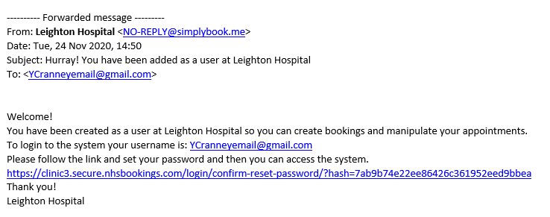

* 1. System web access / URL

The web address for the SimplyBook administration log in screen is in your email.

Copy and paste it into **Chrome**, press enter and save it as a favourite (or access via favourites).

Note: It is important that you open the application in Chrome for full functionality.

* 1. First logon (using email link)

When you click on the link provided in the email the following screen appears

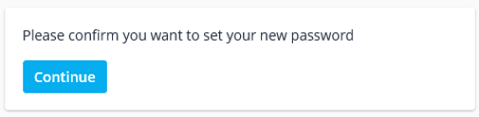

Click Continue, the next box appears.

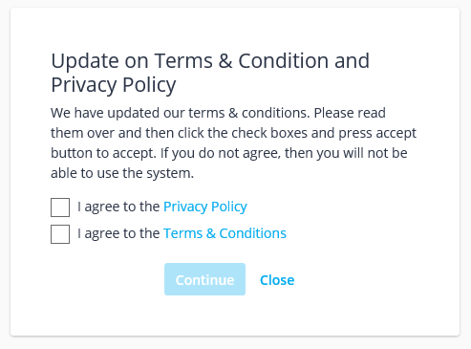

Agree to privacy and T&C’s (tick the boxes & click Continue).

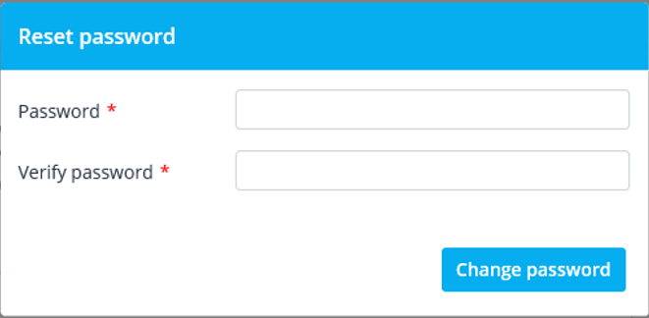

For security reasons, set a new password for your login.

* 1. Logging in to SimplyBook

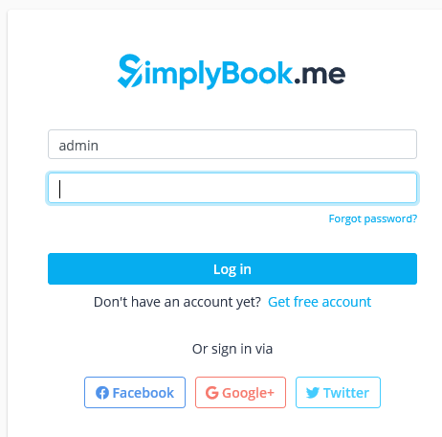

Enter the following information to log you in:

**Username** = Your organisational Email Address

**Password** = will be provided via email

* 1. Setting a new password for the system

If you are not prompted to change your password on first logon, please do the following;

Once you have successfully entered the system, click on the three horizontal bars in the top left of the screen and click ‘Settings’.

You will now need to click on ‘change password’ and follow the steps to make the changes.

It is important that you do this and remember your password.

To ensure a high level of system security your password will need to fulfil a level of complexity:

* 15 x characters
* Must include upper and lower case
* And digit/special characters
  1. Password resets and Requesting a new password

There is a security policy in place for login which allows 5 attempts, if exceeded the system will temporarily block access to the username. If this happens please check that you are using the correct password and that Caps Lock is not on etc., then try again after 5 minutes.

If you have forgotten your password, click on the ‘forgot password’ link at the log in screen, or email [**[Enter relevant email address]**](mailto:Covid.System@mcht.co.uk) for support.

* 1. Making Sure to Log out of the System

You must always ensure that you log out of the system at the end of your shift.

If you do not do this, then you will remain logged in, and other Service Providers may use your log in details to record their work which is NOT best practice.

It is therefore your responsibility to log yourself out of the system at the end of you shift.

Click on your username (top right) and click ‘log out’.

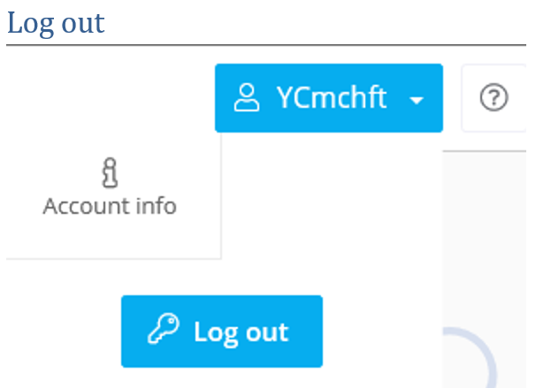

1. The appointment Arrival and Validation process

On arrival for an appointment the service user (Patient/Staff) will need to show the **Doorman** their appointment booking ticket. This could be in paper or electronic format. 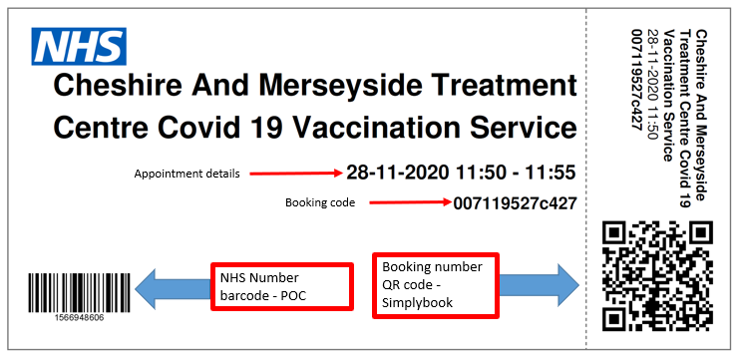

The **Doorman**;

1. Checks date & time on ticket.
2. Scans the ticket into Simply Book system to validate it, recording the patient as arrived.
3. Advises the service user (Patient/Staff) that they will need their ticket again during the appointment.
   1. Validating a Ticket in SimplyBook (if using a desktop computer/laptop)



Log onto SimplyBook via **Chrome**.

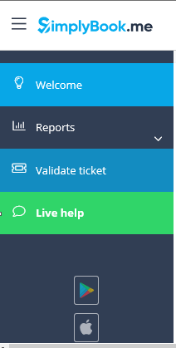

Using the menu on the left side of the screen,

select **Validate ticket**

Or, On the calendar screen click on the **Validate ticket** button.



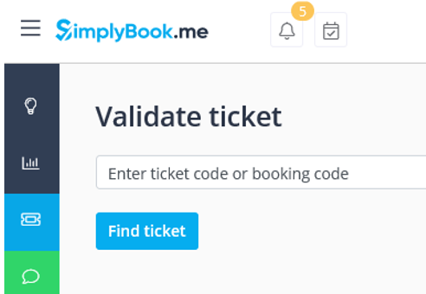

**Click into the ‘Validate Ticket’ field** and use the scanner to **scan the QR code**.

This is best practice and the safest way to avoid manual entry errors.

However, you can key in the code if necessary.

Once the code shows in the field, click **Find Ticket** and the appointment should appear beneath the Find Ticket button.

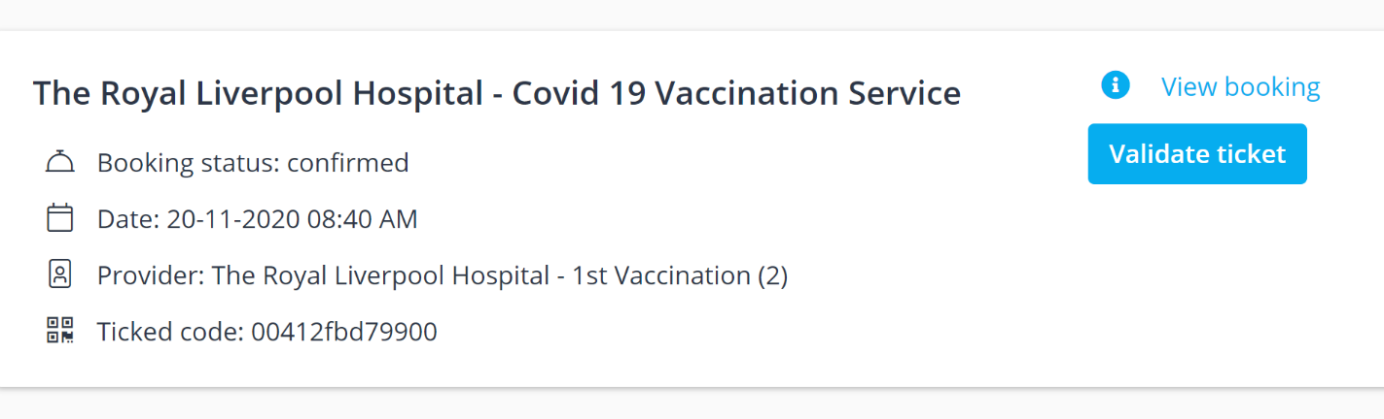

**I*F this does NOT appear – check you are using Chrome as your browser.***

Click on the blue **Validate ticket** button.

Your patient/Staff member has now been arrived and their ticket validated.

Ending the Doorman process and the Staff/Patient is ready for their Vaccination in the clinic.

* 1. If the Staff/patient arrives without their Ticket

If the user does not have their appointment Ticket or booking code the **POS** can enter the calendar screen and locate and enter their appointment to retrieve their booking number and **either** Validate the appointment themselves or pass the booking number across to the Doorman for Validation to occur.

1. How to facilitate a Walk-in Staff/Patient (without an appointment)

It is incredibly important that NHS capacity is managed effectively and unnecessary wastage of vaccines (which may have limited shelf life) is avoided as much as possible.

It is therefore important that everyone who books an appointment attends and that the attendance or DNA is recorded on the system.

The SimplyBook system functionality for Covid 19 vaccine bookings is designed to support bookings made in advance by the service users (Patient/staff) booking via a special link, which will have been sent out to them via email. It will not function correctly if bookings are attempted to be made directly into SimplyBook by the clinic staff. However, it is acknowledged that if spare spaces and vaccines are available the Trust may want to ensure they are used up, therefore a workaround process has been devised.

* 1. Dealing with Walk-ins

If a member of staff presents at your Covid 19 vaccination site without a booked appointment, the **Doorman** should advise the **POS**. If a decision is made to provide vaccination, the **POS** will need to provide facilities for the staff member to log on and book an appointment via the booking website. The staff members NHS number will be required for this.

1. If your organisation is using the App from a Phone

**Organisations will be able to advise their Doorman whether this applies to them, as some sites won’t be using mobile phone devices at their Covid 19 vaccination clinics.**

However, if you have been advised to use a mobile phone and SimplyBook.me downloadable APP to scan tickets, you can find the instructions below.

* 1. Download the Simply Book App onto Service Phone Device

You can find the App in all the app stores. It is called ‘Simplybook.me’.

Download, as you would do any other application and await your login details.

* 1. 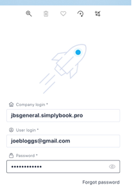Accessing the SimplyBook App for the First time

Open the SimplyBook App, making sure that the last user has logged out. If they have not, please log them out of the App by clicking on the 3 horizontal bars in the top left corner and selecting ‘log out’.

You should now see a screen with a rocket on it.

Enter the following information to log you in:

Company login = [**jbsgeneral.simplybook.pro]** – you must remember this company login. You will need to enter this each time you log in

Username = Your Email Address

Password = will be provided via email

* 1. Set a new password for the system

Once you have successfully entered the system, click on the three horizontal bars in the top left of the screen and click ‘Settings’.

You will now need to click on ‘change password’ and follow the steps to make the changes.

It is important that you do this and remember your password.

* 1. Validate Service User’s QR Code or ‘ticket’ (with a mobile and downloaded app)

These instructions are for organisations that want their Doorman to use the app version on a mobile phone.

Ask the Service User to present their ‘ticket’ (sometimes it’s called a ‘QR Code’).

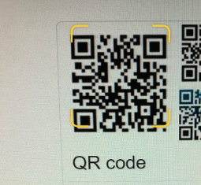They may have this on their own mobile screen, or they may have printed it off.

From the Dashboard screen on the Service Phone Device click on the square barcode icon at the top of the screen (next to the magnifying glass).

When you press this, you will activate the camera on your Service Phone. You should then hold your phone a little distance from the code until the Simply Book application recognises it.

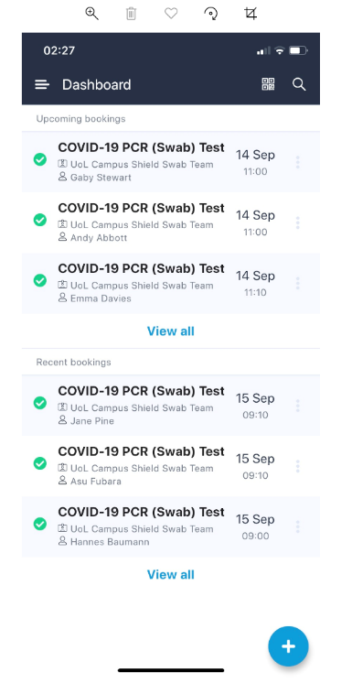When the code is recognised, you will be asked if you want to validate the appointment – make sure that you do validate the appointment.

In the event that you need to enter the ticket number manually you can do this by clicking on the scan icon and select ‘enter manually’

